MACH4METAL

metalworking machinery
Transito 21
6909 DA BABBERICH Netherlands
Tel. +31 (0)316-247123
Fax: +31 (0)316-247956
info@mach4metal.com
www.mach4metal.com

Bank No : 66.52.13.883
IBAN : NL33 INGB 0665 2138 83
BIC : INGBNL2A

3 roll Asymmetric 2000 x 4 mm
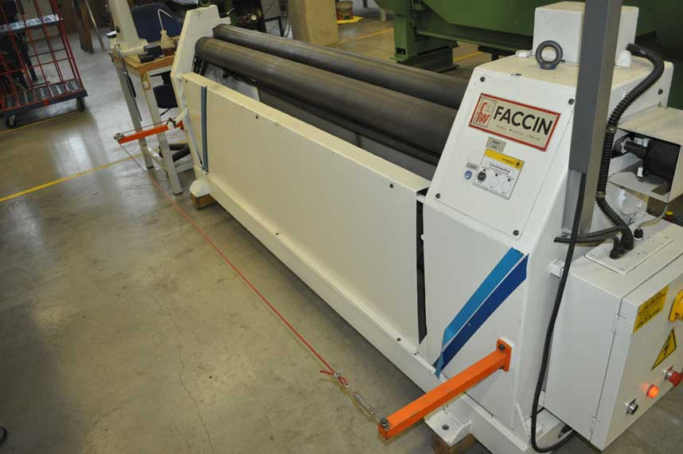
- Make : FACCIN ITALIA
- Typ : ASI / M
- Serial : 2 / 104
- Age : 1996

- Bending length : 2.050
- Bending thickness : 4
- Bending pre bending : 2.5
- Minimum bending Ø : 170
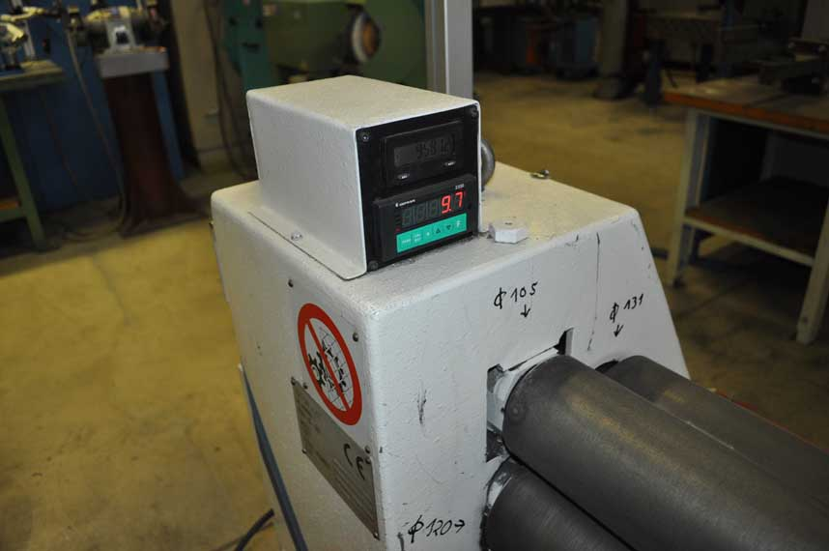
- Top roll Ø : 130
- Lower roll : 130
- Side roll : 130

- Dimensions
- Length : 2.500
- Width : 1.000
- Height : 1.100

- Motorized central rolls
- Digital read out lateral roll

This machine is particularly for miscellaneous production requirements of small size carpentry works. The asymmetrical position of the rolls enables the machine to make the pre bending and also helps the feeding of sheet.
The two central rolls are driven, adjusted through motorized endless screw reducers from foot or handle controls.

Please Note: The above information has been obtained to the best of our ability and belief from, and from the manufacturers where possible. It is given in good faith, but its accuracy can not be guaranteed. Accordingly,it will not form a representation or constitute contractual terms. We advise you to check any vital details!

